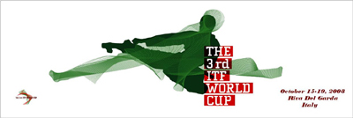

3rd World Cup 2008 - Invitation

Rome, January 2nd , 2008

Dear Members,

This is to inform you that the 3rd World Cup shall take place at the Fierecongressi S.p.A., Parco Lido, Riva Del Garda, Italy from Wednesday October 15th to Monday October 20th, 2008
It will be the 5th major ITF event organized in Italy, as already three European championships, the 2001 Senior World Champs and the 2004 Junior World Champs have been organized in our country.
We are sure that over 1000 competitors take part in this event so that it may become ITF’ s biggest event ever held.
Riva Del Garda, just on the shores of Garda Lake, is a place where you can do something different every day, an ideal place for you! Experience the thrilling emotions of the amusement park “Gardaland” , enjoy the beauty of the natural and thermal parks, visit places rich in history and culture and enjoy the sight of wonderful landscapes

Companies from all over the world fly directly to Rome with a connecting flight to Verona (80 km from Riva), Milan (200 km from Riva), Venice (200km from Riva) and many low budget flights from all over Europe fly to Verona or other close airports

We am very much looking forward to your participation.

on behalf of the Organizing Committee

Yours in Taekwon-Do
Master Willem Jacob Bos, 8th degree

